Book store

1. A store for books, it should look like in the following figure:

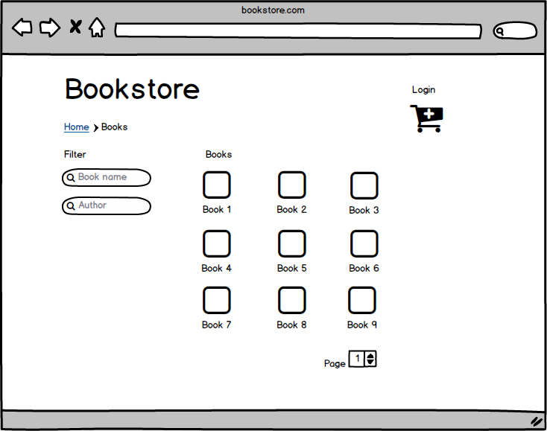

Figure

1. An admin user shall be created directly in the database with rights to create normal users. If the admin user is logged in a menu with options for adding user and adding books should be displayed.
2. When a normal user is logged in a menu for adding books only should be displayed.
3. A book has the following properties: ID, Name, Author, ISBN, Price, Description
4. An author has the following properties: ID, Name, Age, Nationality, Description
5. A user has the following properties: ID, Username, Password, RealName, Email, Type
6. An Order has the following properties: ID, TotalPrice
7. An Order Item has the following properties: ID, OrderID, BookID, Price
8. User type can be Admin or User
9. If you click on a book you will be presented with a screen with all information about the book and its author. Also a buy button will be presented here that when clicked the book will be added to the shopping cart.
10. When clicking the shopping cart button the user will see the list of books and a checkout button which when pressed it will create an order in the database with a corresponding order item for each book and tell the user that the books have been successfully bought. It will also empty the shopping cart upon success.
11. The filter on the left allows filtering the books view by Name and Author. The filtering will be triggered by key pressed.
12. The login button will allow a user to log in with his username and password and after successfull login it will display the User RealName and Logout button.
13. Technologies used:

* Java for the backend
* Apache Tomcat for the servlet container
* MySQL for the database
* HTML, CSS, Javascript for the frontend
* Git for version management